Guidelines for SMART Surveys

on mobile devices

Survey Preparations 3

Personnel 3

Roles and responsibilities 3

Survey coordinator 3

Survey mobile device manager 3

Interviewer teams and supervisors 3

Mobile data collection applications 3

Creating account 5

Data protection 5

Editing questionnaires / ODK forms 6

Uploading questionnaires 6

Deleting or updating questionnaires 7

Installation of questionnaires onto mobile devices 8

Mobile devices 8

General planning, preparation and management 8

Type of devices 8

Number of devices 8

Management of large quantities of devices 9

Device Configuration 11

Preparation of devices 11

Basic configuration of mobile devices 11

Configuration of ODK Collect 12

Configuration of APPLOCK 15

Training 18

Details about devices 18

Settings of devices for training 18

Use of device 18

Use of ODK Collect 19

Completing data entry forms 21

Registration 21

Identification numbers 22

Standardization of Anthropometrists 22

Daily Calibration 27

Nutrition Survey Questionnaire 28

Data Collection 30

Field Test 30

Survey Launch 30

Device exchange 30

Daily Data Quality Review 30

Finalization of data 30

Improvements

Explain how to number trainees

Explain how to do daily calibration

Only one set of equipment per day

How to collect the number of households

Explain numbering of MUAC strips

# Survey Preparations

Collecting data with computers may appear to be new and innovative but one of the first documentation of CAPI computer assisted personal interviewing was in 1987.

Do not use paper questionnaires with the data entry on mobile devices. Always choose only one approach and continue with its use throughout the survey Using paper questionnaires and questionnaires on mobile devices is overly complicated and introduces keying error. It is difficult for teams to complete both questionnaires, even when they are well trained and supervised.

Verify with CDC that this will be accepted.

## Personnel

### Roles and responsibilities

#### Interviewer teams

Interviewers will be trained and tested all together at the training site. Teams normally are formed of one team leader, an anthropometrist and an assistant. The schedule of villages/clusters selected for the survey will be given to each team. After training, the teams will go directly to collect data in the field.

Interviewer teams normally work in one cluster per day. They usually complete interviews for around 20 households per cluster. Team members will weigh and measure women and children and enter the data onto the tablet. The team leader will be responsible to ensure that data are entered, saved and sent to the coordination team on a daily basis.

#### Survey coordinator and Supervisors

The survey coordinator and any supervisors are responsible to ensure data collection is completed and send on a timely basis and to provide feedback to teams on implementation issues.

#### Survey mobile device manager

Ensure all mobile devices are updated, loaded with the proper ODK questionnaires and parental lock applications.

Ensure that all mobile devices are in perfect working order.

Collect all mobile devices and store in a suitcase with a lock.

Maintain all necessary paperwork to track the mobile devices in the suitcase to assure close follow up of the distribution and return of devices. Ensure no theft, damage orloss of mobile devices

## Mobile data collection applications

KoBo Toolbox <https://kobo.humanitarianresponse.info>

National or privately hosted servers for of mobile data applications such as ODK aggregate are not recommended as it is difficult to ensure 24 hour electricity, internet connectivity, IT support for updates, security and technical problems.

KoBoToolbox is recommended as it is available at no cost for UN and humanitarian actors. It is hosted by OCHA

Use of UNICEF purpose built nutrition survey dashboard to track conditions of data collection during the fieldwork. The dashboard provides daily feedback on the progress of data collection and will help the survey technical committee stay aware of the pace and quality of data collection.

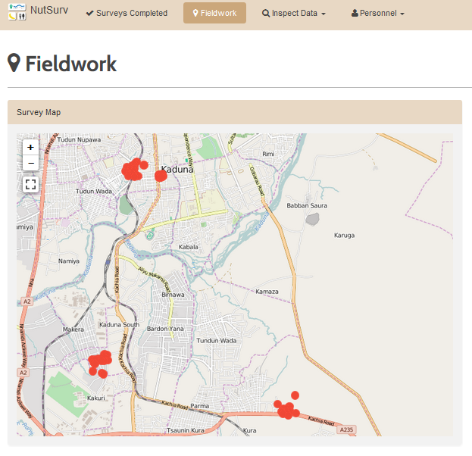

Visualization from Nutrition Survey Dashboard

### Creating account

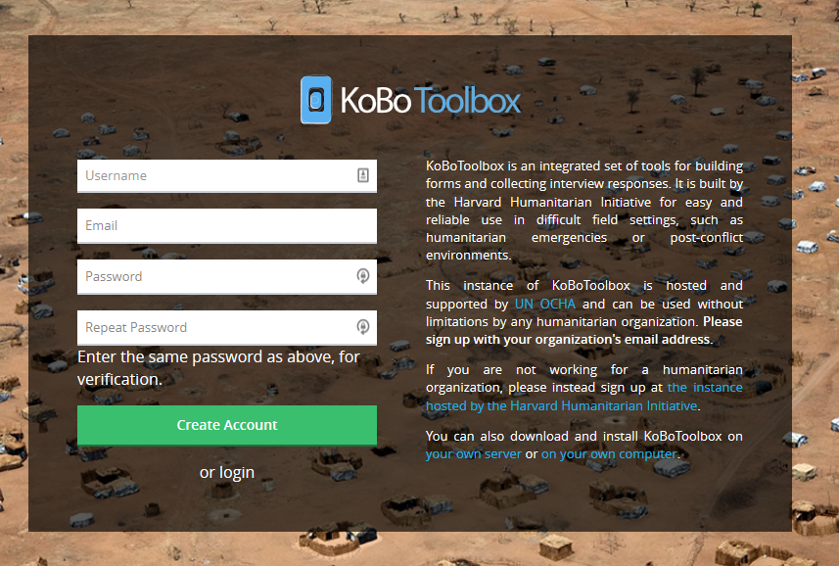

Create account page in Kobo Toolbox

To create a Kobo Toolbox account on the UN OCHA hosted version, go to the link below. <https://kobo.humanitarianresponse.info/accounts/register/>

Note your KoBo Toolbox account username and password in a safe and protected place to ensure that access to the account is never lost. During the configuration of the mobile devices, you will be typing your account name and password several times for each mobile device. You can save time during the configuration process by using a short Username and easy Password. You can always change the password to something more secure/complicated after the configuration process is complete.

It is recommended for the survey device manager to register with a separate personal account. The survey coordinator will have to give the rights for the survey device manager to access the projects related to the survey.

To give rights to the survey device manager, follow the instructions below.

http://support.kobotoolbox.org/customer/en/portal/articles/2103898-managing-permissions

### Data protection

Data security and protection

Password protection

Control over rights to access

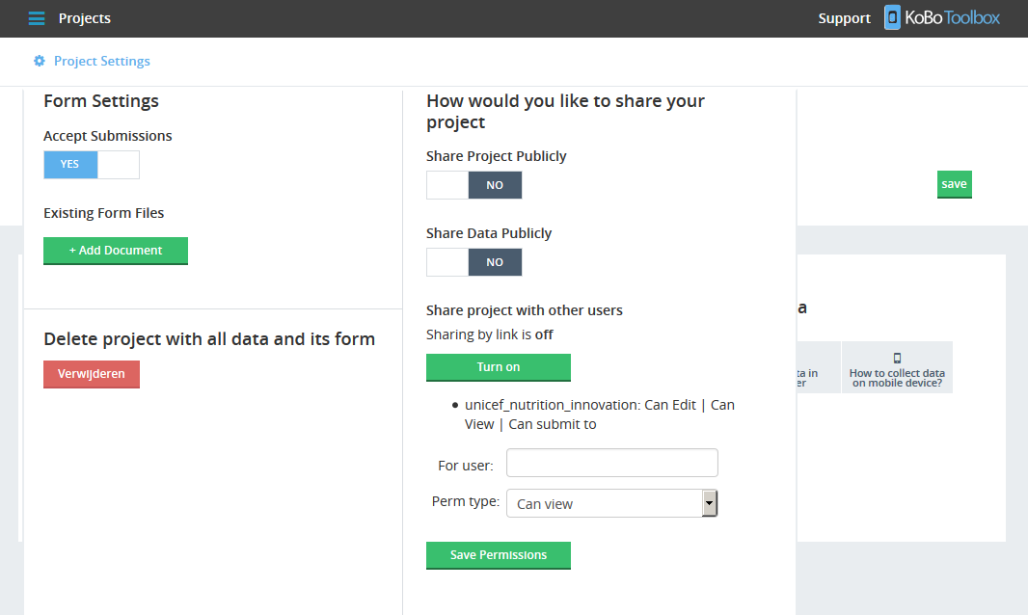

### Editing questionnaires / ODK forms

The questionnaires / ODK forms must be updated with country specific details before use. To update forms, document all necessary information in advance such as:

* Cluster and reserve clusters numbers and range (for example from 1 to 120)
* Names and code numbers for 1st administrative levels (regions, states, provinces)
* Names and code numbers for 2nd administrative levels (districts, LGAs, counties)
* Names and code numbers for clusters (if available)
* All important languages spoken in country to be used during data collection.

For more information on how to use ODK Collect, please see…

### Uploading questionnaires

To upload the SMART questionnaires:

1. Click on the *three blue bars*, also known as the menu, on the top left of the KoBo Toolbox page.
2. Click on *Projects,*  in the pop-out menu on the left of the page
3. Click on A*dvanced Users: Upload your XLS form here directly,* on the foot of the page.
4. Select the questionnaire / ODK form that you would like to upload
5. Click on *OPEN.*

If the ODK form that you have selected does not have any errors, the questionnaire will appear in the list.

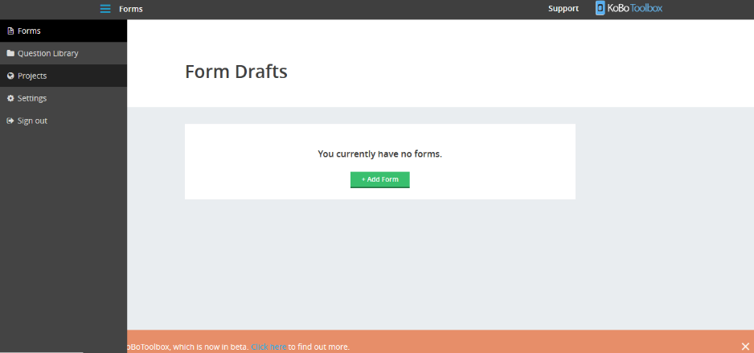

### Deleting or updating questionnaires

Start on the Projects page to delete or update the questionnaire / ODK form:

1. Click on the *name of the questionnaire* in the projects list.
2. Click on *Project Settings* on the top left of the screen.
3. Click on *Delete project with all data and its form.*  This will remove the questionnaire.

You can update questionnaires only if you have not collected any data. To update a questionnaire – go to the Project Settings page, underneath the Submissions section, you will see the Form section, click on the refresh icon . You will be asked to identify and open the new file to update the questionnaire.

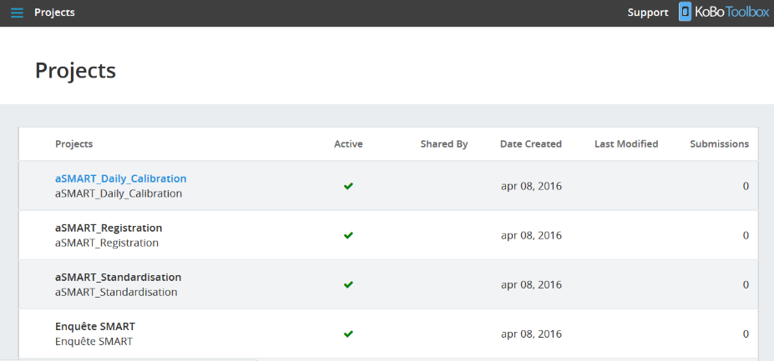

### Installation of questionnaires onto mobile devices

Once you have uploaded your country or case specific versions of the following questionnaires / ODK forms, you are ready to prepare and load the forms onto the mobile devices for testing, training and data collection.

The four forms to upload to devices for nutrition surveys are:

* SMART_Registration.xls
* SMART_Standardization.xls
* SMART_Daily_Calibration.xls
* SMART_Questionnaire.xls

## Mobile devices

Before procuring mobile devices, it is important to identify who are the major supplies of device sin the country where you work. Often the mobile devices and sim cards are available as a package with significant discounts for purchasing the data plan along at the same time as the mobile device.

### General planning, preparation and management

#### Type of devices

The selection of mobile devices is very important for the success of the survey. It is strongly recommended to test out the type of mobile devices that you intend to purchase for the study before you purchase the devices in quantity. Some devices are slow or are poorly configured for use with Open Data Kit.

Before purchase, verify that the preferred Mobile Devices have:

* Android 3.0 operating system or higher. Most tablets from 2013 have Android 4.1 (Jelly Bean) or higher
* SIM card slot
* 3G / Edge network and WIFI enabled
* GPS with a precision of at least 5 m

For surveys, it is recommended to use Samsung Galaxy 7 inch tablets or similar. It is not necessary to use this type of tablet, but they are solid, with strong battery life and are available almost in every country. This size of tablet has a large screen but is easy to store in a pocket or bag when not in use.

The survey can be completed on android mobile phones. The screen size is smaller, the questionnaires are more difficult to read and the buttons and keyboard to enter data are smaller making keying errors more frequent.

It is recommended to purchase appropriate sized covers for the devices to protect them from water, rain, humidity and direct sun. All users of the mobile devices will sign a contract to document their responsibilities to maintain the devices undamaged and in good working condition.

#### Number of devices

It is recommended to have two mobile devices for every team (10 teams = 20 mobile devices).

Every team during the survey should have two mobile devices for data collection, one device for data collection and one device in reserve. If there is ever any problem with the device such as a technical issue or drained battery, the team has a spare device to continue with data collection.

#### Management of large quantities of devices

It is critical to work closely and carefully with the mobile device manager from the beginning of the survey to protect devices from loss or damage. There are many simple ways to protect the devices that should be adopted as part of normal operations from the start of the survey.

1. **Number all devices and their containers / protective packing with fingernail polish, an etching pen or permanent marker on duct tape.**

Ensure that your numbers can be read in one orientation and are not interpretable as a different number if the device is turned 180 degrees.

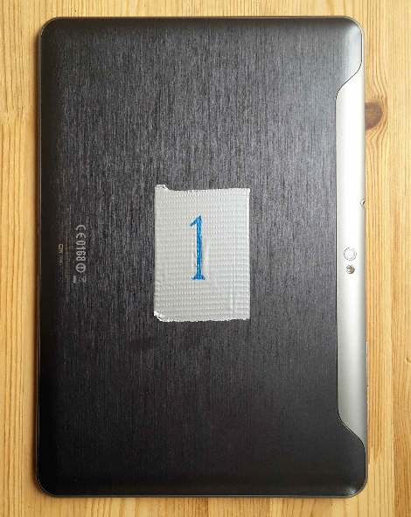

1. **Store the mobile devices in a suitcase with lock**

When the mobile devices are not in use for survey, keep them locked in a dedicated suitcase.

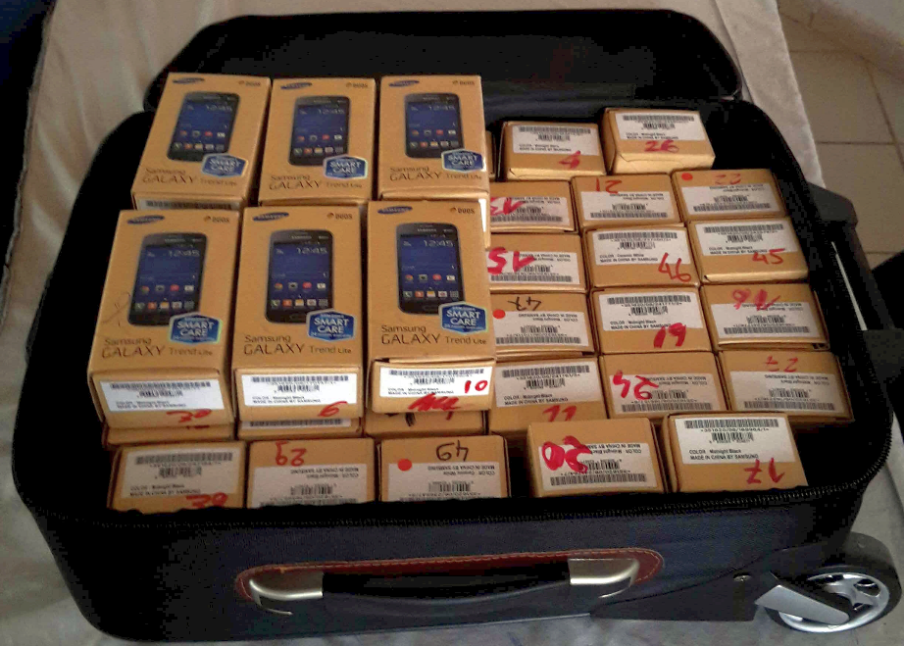

1. **Work in private / protected work spaces with the minimum number of authorized persons in the room where you are working with mobile devices.**

Closing the room or work space to unauthorized persons during configuration of devices helps to prevent theft or losses.

1. **Always store the devices in the suitcase in order.**

When storing the devices in the suitcase or any other location, always store the devices in order so that it is immediately obvious if any of the devices are missing.

1. **Always store the devices correctly in the cover and packaging provided at purchase**

When storing devices, it is critical to put them in the cover and/or packaging correctly to prevent damage to the device, loss of cables or drainage of battery.

1. **Always position the mobile devices in order when working with more than one device at a time.**

Arrange the mobile devices in order on the table (from 1 to 20, for example) if working with more than one device at a time. This approach allows you to immediately identify if any device is missing.

1. **Before starting the training with mobile devices, ensure that everyone working with the survey signs the contract on UTILIZATION OF MOBILE DEVICES.**

The contract for UTILIZATION OF MOBILE DEVICES during the survey must be signed by everyone working with the survey starting with the survey technical committee, the survey coordinator and the survey device manager. Before allowing the trainees and supervisors to use the mobile devices, they must also sign the contract (provided in annex). All persons involved in the survey have to take responsibility to prevent any damage to the mobile devices.

* Everyone using a mobile device must sign contract for issue of device
* Data collection teams of three person take joint responsibility to maintain devices in good condition and undamaged.
* Supervisors or other persons working outside of teams take full responsibility for the device(s)
* Any device damaged, destroyed, lost or stolen will be replaced by those responsible as recorded on the contract.

As the personnel must be on contract at the beginning of the training, they will lose future earnings (greater than cost of tablet) from the survey working period.

1. **During training and before launch of the survey, always ensure that survey staff sign in and out with devices**

If the mobile devices are used during the training and returned to the survey device manager at the end of the training exercise or training day, the devices must be signed out and signed in to prevent theft, loss of cables, plugs, sim cards or other parts.

### Device Configuration

Materials needed:

* Private and protected workspace
* Mobile devices
* WIFI
* SIM Cards
* Extension cords with multiple plugs

#### Preparation of devices

For the initial preparation and activation of mobile devices

1. Arrange all numbered devices in order (from 1 to highest number) on tables/work space
2. Plug in all mobile devices to extension cords to charge batteries to 100%
3. Turn on WIFI and enter WIFI password and verify that WIFI connection is working
4. Allow mobile device to update the operating system and software as needed
5. Insert SIM cards and verify that mobile data plans are functioning

##### Basic configuration of mobile devices

1. Set the correct date and 24 hour time. Always use the DD/MM/YYYY format
2. Remove all non-relevant icons and widgets from the desktop
3. Set Bluetooth to off.
4. Turn off all vibrate options. Set Vibrate on screen tab to off.
5. Set screen time-out to be long for training (5 minutes)
6. Check the box for Auto adjust screen power – to protect battery life during training and data collection
7. In Location Services, check the box for Use GPS satellites to identify location accurate to street level.
8. Set Language to the native language of the data collectors
9. Click on Google Play. Swipe from left to right on the Google Play page to access settings. Under General, set Auto update apps over WiFi only.
10. Set the keyboard to be Touch Input and change the settings to remove all spell checking and suggested works. Test the calibration of the keyboard.
11. Calibrate the GPS. Click on maps with GPS on and with an unobstructed view of the sky. The first time you use GPS in a new place, it can take 20 minutes to load the location. Don't make the trainees do the calibration as it wastes valuable training time. After the first GPS reading is made, the next GPS reading in the same location will be faster.

##### Configuration of ODK Collect

1. Uninstall any old versions of ODK COLLECT if the mobile devices have been used previously.
2. Download ODK COLLECT version 1.4.7 or higher onto all mobile devices. Go to apps, find the Play Store, and double click to open the application. Enter ODK COLLECT in the search window to find the ODK COLLECT download page. Click on Install.
3. Place the icon on the desktop.

*General Settings*

1. To link the mobile device with your KoBo Toolbox account, click the three dots on the top right of the ODK Collect > Main Menu page, click *General Settings,* then under the headingServer Settings*,* click *Configure platform settings.* This will take you to the ODK Aggregate Settings page.
2. Click on *URL* and enter - <https://kc.humanitarianresponse.info>
3. Click on *Username* and - enter your account name
4. Click on *Password* and - enter your password

Under the heading **Auto Send**

1. Check box for *Auto send with WIFI*
2. Check box for *Auto send with network*

Under the heading **User Interface**

1. Click on *Constraint processing behavior,* then click on *Validate upon forward swipe.*
2. Click on *Navigation* and select *Use forward / backward buttons*. This navigation method helps to avoid keying errors.
3. UNCHECK the box for *Default to finalized*
4. Check the box for *Delete after send*

Admin settings

1. To configure the admin settings of the mobile device, click the three dots on the top right of the ODK Collect > Main Menu page, click *General Settings*.

Under the heading **User Can Access Main Menu Items**

1. Check the box for *Edit Saved Form*.
2. Check the box for *Send Finalized Form*.
3. UNCHECK the box for *Get Blank Form*.
4. Check the box for *Delete Saved Form*.

Under the heading **User Can Access Change Settings Items**

1. UNCHECK all options

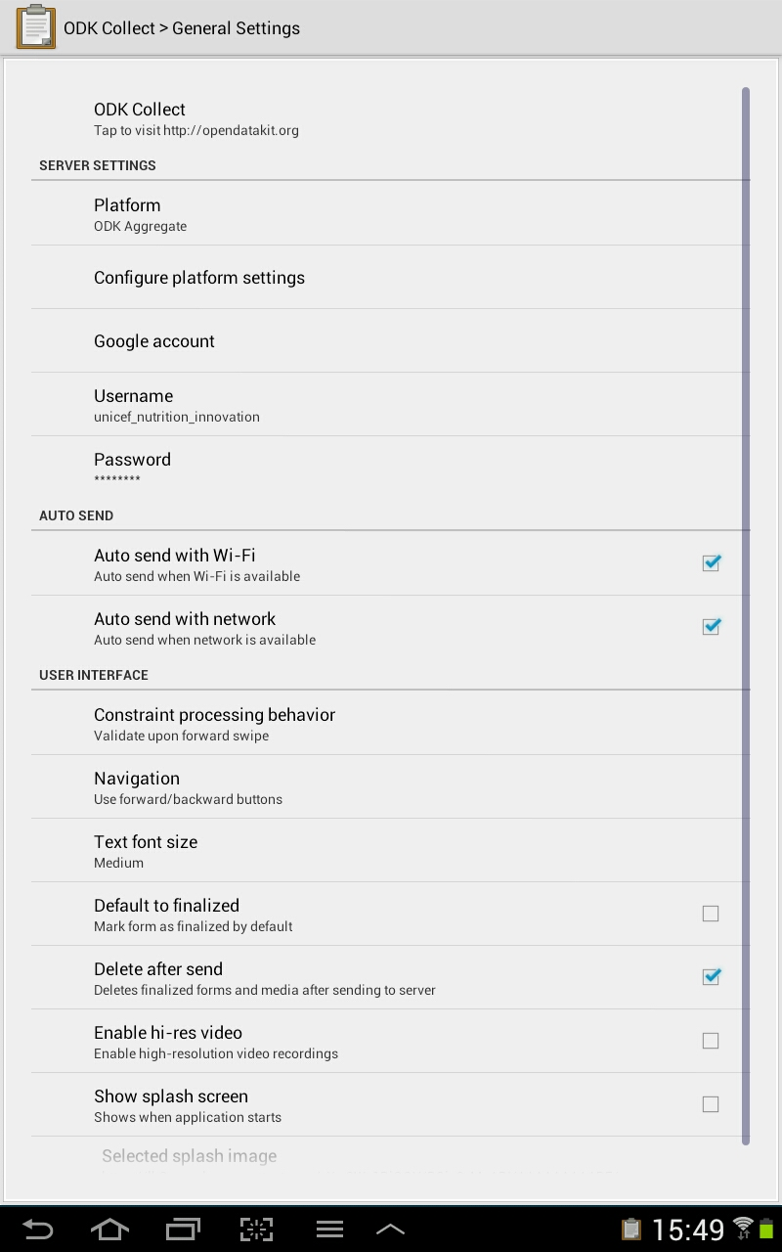

Under the heading **User Can Access Form Entry Items**

1. UNCHECK the box for *General Settings*
2. UNCHECK the box for *Change Language*
3. Check the box for *Go To Prompt*
4. Check the box for *Save Form*
5. Check the box for *Name This Form*
6. Check the box for *Mark form as finalized*

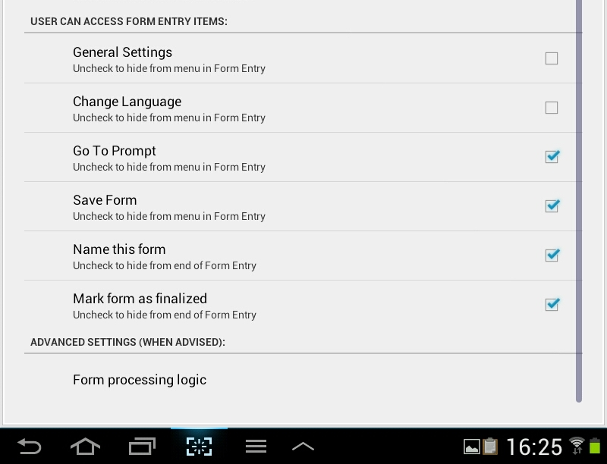

1. Set ODK Collect admin password protection to ensure that interviewers do not re-configure ODK on the mobile device.

To lock ODK Collect with an Admin Password

* Open Admin Settings
* Click on *Admin Password*

If there has been a password entered previously, the application will ask you to:

* Enter New Password
* Re-enter New Password

Please note, this page is difficult to read. Look closely and you will see the words in white on a white background.

Turn off ODK Collect and restart to see the Admin settings take effect. You should never need the default Admin password, but just in case, it is “aggregate”.

If you find that the three dots at the top right of the screen (for the general and admin settings) are not available, you can click the menu icon (three lines) on the bottom of the device screen to access the settings. Enter your password and make the necessary changes.

For more information about the steps above, see the ODK website at opendatakit.org or <https://groups.google.com/forum/#!forum/opendatakit>

##### Configuration of APPLOCK

1. Download a parental protection application such as APPLOCK onto all mobile devices. Find the Play Store, and double click to open the application. Enter APPLOCK in the search window to find the APPLOCK by DoMobile Lab download page.
2. Click on Install.
3. Click on Open
4. Create your password (numerical code) and re-enter
5. Enter an email address for security, if you would like.
6. Place the icon on the desktop.
7. Configure AppLock by locking all the applications and options that you do not want the interviewer teams to change during the data collection.
8. Do not lock the following
   * Incoming calls
   * Calendar
   * Calculator
   * Maps
   * ODK Collect

Please follow the configuration given in the picture below.

There are options in the APPLOCK application to have an icon that turns off APPLOCK in the settings menu on the bottom right of the mobile device. These are not recommended.

It is best practice to use APPLOCK as recommended above or uninstall when it is not needed.

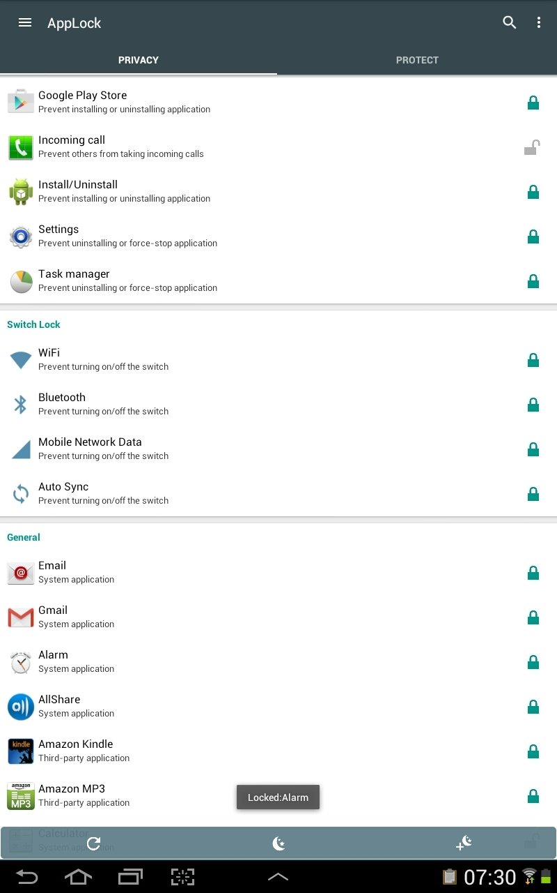

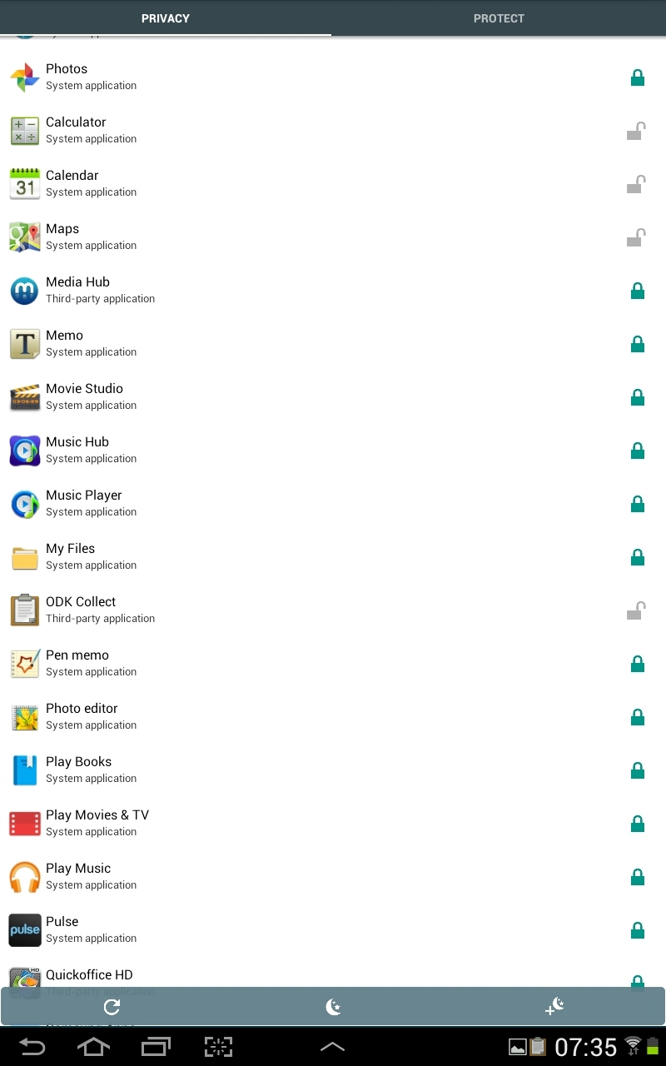

## Training

### Details about devices

The battery life of the device is about 9 hours continuous use and for several days when resting.

The team leader is responsible for charging the battery of device and ensuring that the device is ready for a full day of data collection. The device must be kept clean, dry and out of direct sunlight and or excessive heat for long periods.

Any malfunction of the device should be reported to the survey coordination team. Most problems can be resolved over the telephone. The survey supervisor or coordinator can provide a replacement device on demand after review of the problem.

#### Settings of devices for training

* Set screen time-out to be short during fieldwork to ensure the battery will last all day.
* Test all devices before training. Open all questionnaires for the first time to make sure they are working. The form will faster after the first use.
* If not using WIFI, turn off WIFI in settings of the mobile device. This will save battery power. Be careful. If you set all WIFI off in all mobile devices and you need to make a small update, you will have to set WIFI to on to make the change on all devices.

**Attention**

* **The Standardization exercise will use a different configuration of ODK for the collection of the anthropometry of 10 children twice.**

### Use of device

Discuss the basic rules of use of mobile devices with all of the survey personnel.

Basic rules

* The mobile device is not your camera, toy, a radio or movie player
* If any survey personnel reformat or hack the device, they will be dismissed
* All survey personnel are responsible to protect the device from damage or loss
* Do not use the device for personal reasons
* Do not show off the tablet during or after data collection
* Keep the device out of site in survey bag when not using it in data collection in field
* Keep the device in protected case and/or box when traveling

General instructions for use of device

* Turn the Android on and off
* Put the Android in sleep mode
* Turn the volume up and down
* Swipe the screens (open device from landing page)
* Go to the HOME page
* Do a short press
* Do a long press
* Select a program
* Turn on and off Maps application
* Turn on and off ODK Collect
* Demonstrate keyboard (for example in registration form)
* Demonstrate number pad (for entry of numerical data)
* Demonstrate date data entry (for entry of dates)
* Be careful with swiping the screen – you can accidently enter incorrect data

### Use of ODK Collect

To start ODK – click on ODK Collect icon

To open questionnaire list – click on *Fill Blank Form*

To open questionnaire – click on name of selected questionnaire

Question and answer types used in ODK questionnaires

* Yes / No
* Select one answer
* Select multiple answers
* Answer with number
* Answer with Text

How to make corrections

* Navigate to question to correct
* Click on the answer cell to put the blinking cursor in place
* Use the backspace button to delete the incorrect entry
* Enter the correct answer
* Click on arrow on lower right to enter and advance to the next question

Add New Group? - Entering data to a list

In some cases, such as listing all household members, we need to enter all members from the first to the last. To enter data into this type of list:

* At the *Add New Group?* prompt, click *Add Group*
* Answer all questions
* If there is another person or thing to add to list, click *Add Group* again
* When you complete the questions on the last person or thing, click *Do Not Add*
* This ends the list and continues with the questionnaire.

If you make a mistake in the list – and have clicked *Add Group* when the listing was complete:

* Navigate to the question in the Add Group list
* Long click on the answer
* When the *Remove Group* prompt appears, click *Remove group*.

How to navigate through questionnaire

Navigate question by question

* Use the arrows at the lower edge of screen

Navigate directly to a question

* Click on the *Arrow to Dot* icon on top right of screen
* Scroll to and click on question that you would like to go to.
* If your question does not appear, click *Go Up* in bottom left of screen

Explain the levels of a questionnaire

* Main questionnaire
  + Descend to household listing
* Return to main questionnaire
  + Descend to Child Section
* Return to main question
  + Descent to Woman’s Section

How to save a questionnaire if interview is interrupted

* Click on the Disk (save) icon on the top right of screen
* In the cell below *Name this form,* type the name of the questionnaire
* Different questionnaires will use different name conventions
* Do not check the box – *Mark form as finalized*
* Click the button *Save Form and Exit*

How to exit a questionnaire without saving

In some cases of errors of identifying households, an interviewer may start a household interview and realize that they have started a questionnaire for a non-selected household. To exit the questionnaire without saving:

* When in a form collecting data, Click on the back button twice – on the lower left hand corner of the screen
* The prompt will ask Exit Survey – *Ignore Changes*
* Touch *Ignore Changes* and no data will be saved from the opened questionnaire
* You will return to the questionnaire selection page.
* If you touch – *Cancel* instead of I*gnore Changes*, you will return to the questionnaire where you stopped.

How to send completed questionnaire to server

* Check Cluster and Team Leader ID is correct
* Check Listing of Household Numbers are correct
* Ensure that all appropriate data are collected
* Go to end of Questionnaire
* Check the box - *Mark form as finished*
* Click the button *Save Form and Exit*

Typical problems encountered in the field

The ODK application can crash. Encourage the trainees to explore how to use the device. If they find errors and other problems, show these error messages to everyone and demonstrate the appropriate response to each type of error. The main types or errors are:

* Data entry form closes accidentally by hitting the wrong key
* Data entry form closes without explanation

To demonstrate these types of issues, close the data entry form in mid interview. Hit the home button, run another program, then open the data entry form again. On re-entry, the screen may show:

* the main menu,
* a screen from the last survey,
* or rarely the collected survey data was lost.

Demonstrate how to deal with each condition. Emphasize the importance of saving the questionnaire if there are interruptions and/or completing and submitting the survey to prevent loss of data.

Some data entry errors can cause ODK Collect to crash. It is important to know these in advance to prevent these errors. Two recognized data entry errors are:

* If the interviewer changes the sex of an eligible woman to a man
* If the interviewer changes the age of eligible child to an older age.

If the interviewer arrives at an error message such as the one below, the interviewer team will need to delete the questionnaire with errors and start the household interview again at the beginning.

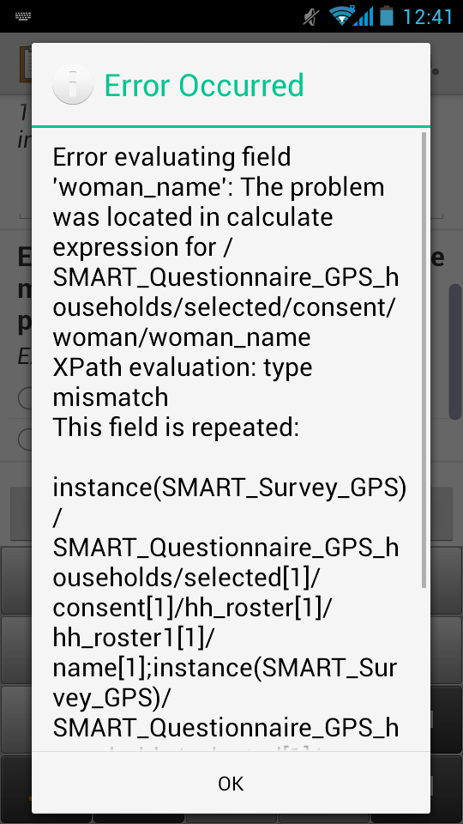

#### Completing data entry forms

##### Registration

Everyone working on the survey should register with the mobile device. This includes the survey coordinators, technical team, trainees and support staff. The survey registration questionnaire takes 2 minutes to complete. Once everyone has registered, the survey coordination has a complete list of all personnel working on the survey. This is valuable in countries where there are repeated surveys every few years.

The registration data entry forms collects information on:

* Names
* Gender
* Age
* Contact information
* Language spoken

##### Identification numbers

Each person working on the survey must have an ID number. This includes those persons who will be trained as interviewers and the survey coordinators, technical team, and support staff. With the exported data from the registration questionnaire in an excel format, an identification number can be added in a column starting from 1 to the highest number corresponding to the last person in the registration data.

Identification numbers will be used throughout the survey to identify survey personnel. This information will be used to determine:

* Who worked where and when,
* Salary payments for number of days worked,
* Responsibility of good or poor quality of data.

Trainees should clearly understand that if they do not accurately record their IDs, they will not receive their full salary. If there is no record of their work during the survey, they will not be considered to have worked.

#### Standardization of Anthropometrists

There are a few differences in the configuration for mobile devices that are needed to use the mobile devices to collect data for the standardization of anthropometrists. The changes in the ODK Collect configuration make it difficult to copy data, because:

* Only new empty questionnaires can be opened
* Completed questionnaires cannot be saved or reopened for edits
* Completed questionnaires are set to *Finalized* automatically, and
* *Sent by WIFI* or *Sent by Network* immediately once they are completed.

It is not necessary to reconfigure all mobile devices, only the number that are needed to complete the standardization exercise. Select a certain number of the mobile devices for configuration for the standardization exercise, such as numbers 1 to 16. Normally you would need only 10 devices for 20 trainees to complete the exercise. But you will want to have some extra configured devices to ensure that there are no device problems that prevent everyone from completing the exercise. It is best practice to complete the standardization exercise with a maximum of 20 persons at one time (10 teams of two persons).

The methodology of the standardization exercise must be carefully explained to all trainees before starting the session. It necessary to communicate clearly to all trainees that they will be supervised and if they cheat, they will most likely be caught. All trainees cheating will be removed from the training and will no longer be considered as potential data collection personnel.

Configuration: ODK Collect > Admin Settings

UNCHECK box for *Edit Saved Form*

UNCHECK box for *Send Finalized Form*

UNCHECK box for *Get Blank Form*

UNCHECK box for *Delete Saved Form*

UNCHECK box for *Save Form*

UNCHECK box for *Name this form*

UNCHECK box for *Mark form as finalized*

UNCHECK box for *Go to prompt*

And

Configuration: ODK Collect > General Settings

Check box for *Auto send with WIFI*

Check box for *Auto send with network*

Check box for *Default to finalized*

Check box for *Delete after send*

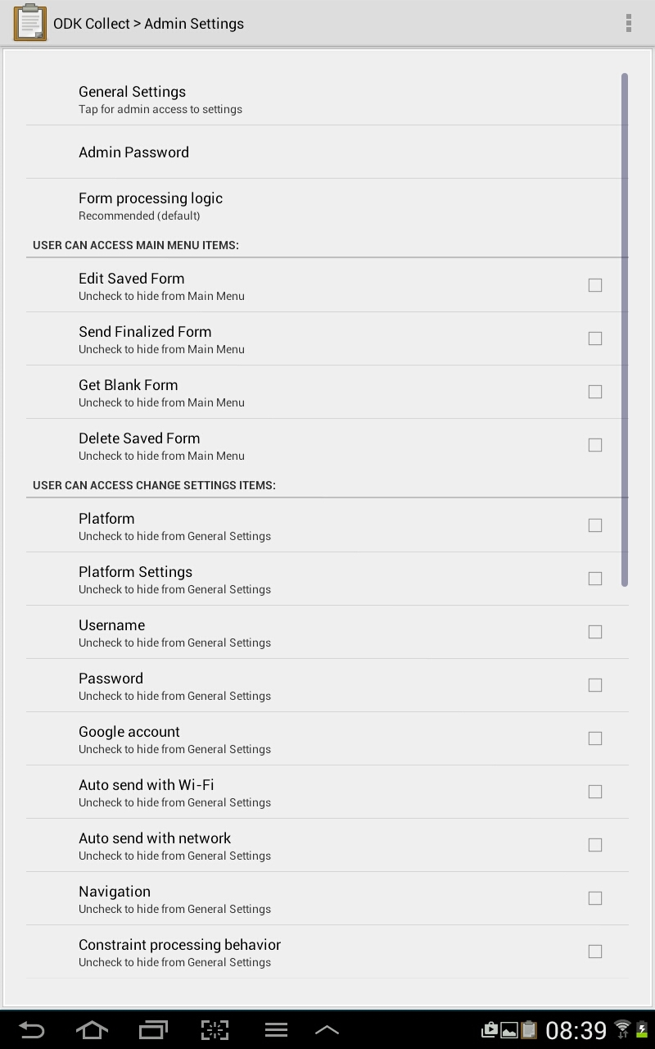

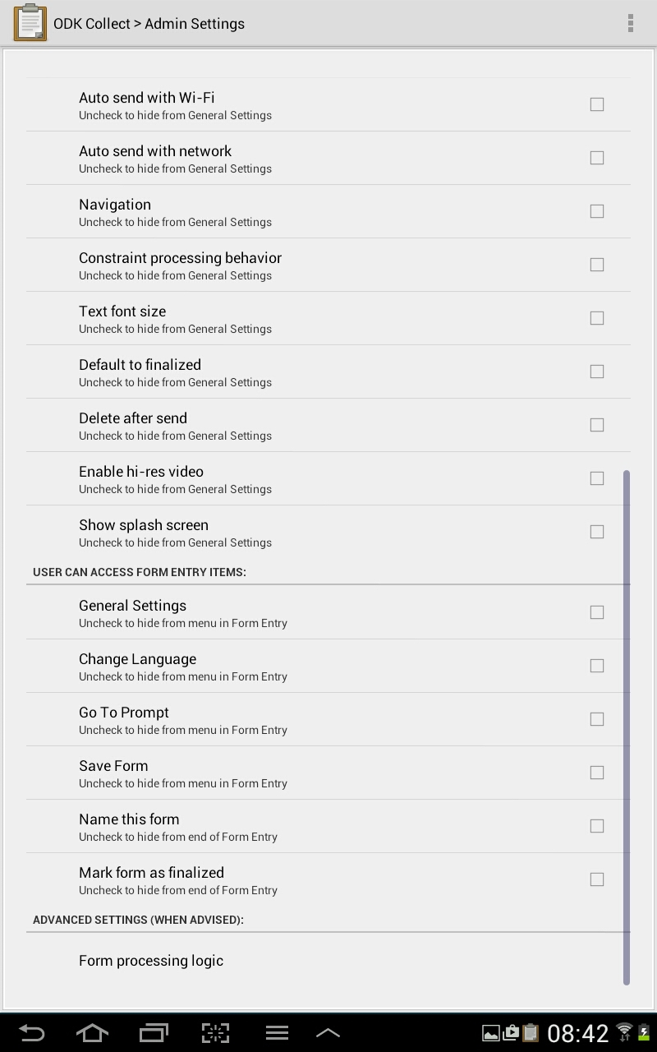

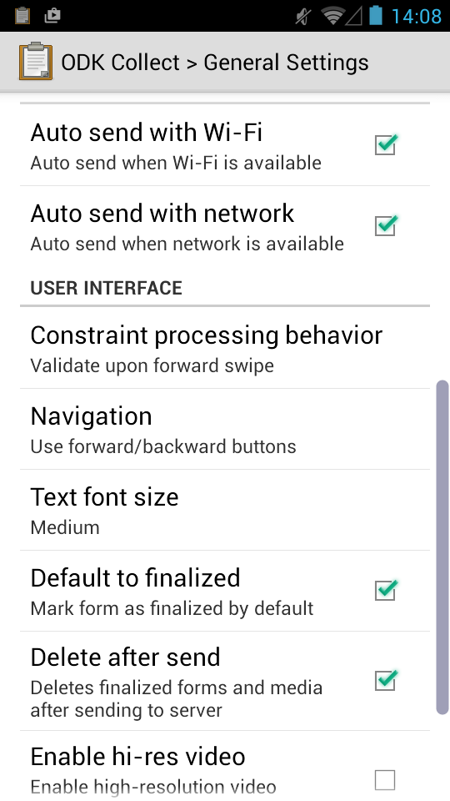

In the questionnaire for the Standardization exercise, the trainees will enter data on:

* Session number
  + Each standardization will be assigned a session number.
  + The first exercise with 10 teams should be assigned number 1 and the numbering should continue consecutively.
  + It is not recommended to have two standardization exercises at the same time as supervision is often less than adequate. If there are ever two standardization exercises conducted at the same time, ensure that they are assigned different session numbers.
  + If session numbers are not assigned, the automation of analyses will not function
* ID number of the Anthropometrist
  + During the standardization, one trainee identified as the anthropometrist is responsible to measure the child, read the measurement instrument and record the result.
* ID number of the Assistant
  + As the standardization exercise is always conducted in teams of two persons, the second person participates as the assistant.
  + The assistant supports the anthropometrist to put the child in place or correct position for measurement.
  + The assistant does not measure the child, read the measurement instrument or record the result.

At each post, the following specific information about the child is recorded on a piece of paper to correctly identify the child.

* Child ID
* Child Name
* Gender
* Age in months
  + The age of the child is important for determination of making a height measure standing or recumbent.

The anthropometrist will be responsible to measure and record the follow data of the child.

* Weight (kg)
* Height (cm)
* Measure
* MUAC (cm)

Once the standardization exercises are completed, all mobile devices must be returned to the default configuration described at the in the Device Configuration section above in the document.

#### Daily Calibration

The daily calibration questionnaire is used to:

* enter the ID numbers of team members,
* the number of households, population in the cluster and segment
* ensure that all measure tools are in reviewed daily and are in good working order,
* record the GPS point and time when data collection starts in the cluster.

The data collected are:

* ID numbers of
  + Team Leader
  + 1st Anthropometrist
  + 2nd Anthropometrist
* GPS point
* State, Region or County
* Cluster number
* Number of households in the CLUSTER (if known)
* Number of households in the SEGMENT (if known)
* population of the CLUSTER (if known)
* population of the SEGMENT (if known)
* ID number and standard measure of
* Height board
* Digital scale
* Adult and Child MUAC strips

#### Nutrition Survey Questionnaire

The Nutrition Survey Questionnaire has some small differences for the listing of household numbers. These are described below.

ADVANCE ENUMERATION OF CLUSTER AND RANDOM HOUSEHOLD SELECTION

Use the sample list and map of cluster to identify selected households

Enter the identification information for the selected household

Record the GPS point at door before entry of the household

Request consent and continue with interview

SYSTEMATIC RANDOM SAMPLING (List and Go)

If the survey technical team decides to use the list and go method:

* Meet with village chief to ensure permission to conduct survey
* Select the random start number (0 to 6)
* Calculate the sampling interval
* Approach door of first household or concession (address)
* Record number of household(s) with chalk on door
* If any household are selected, circle the number of household on the door
* Enter cluster number
* Record all the household number(s) at address
* Record if there is a selected household at this address
* Record HOUSEHOLD NUMBER selected
* Please take the GPS reading at the door

If there are two selected households at the address, repeat the process and enter the exact same information. That is, pretend you start again outside of the main door if there is more than one selected household.

After completing the list of household numbers, request consent for selected households and complete the interviews.

After entering the ID information on the selected households, the interviewer team will:

* Complete the household listing by recording for all household members:
  + Name or nickname for identification purposes in the household only
  + Age
  + Sex

The questionnaire will automatically select all children less than six years of age. The under six year cut-off is used to prevent problems of age shifting. The exact date of birth or age in months will be collected for children under six years of age. Then from the most precise data on age in months, the following data will be collected on children under 5 years of age (under 59 months):

* Weight
* Height
* Measure (recumbent length or standing height)
* MUAC
* Bilateral edema

If there are any other questions collected on children, they are collected before advancing to the next section of the questionnaire.

After data collection on children, the main questionnaire collects anthropometric data on women. For all women from 15 to 49 years of age, the following data are collected:

* Weight
* Height
* MUAC
* Pregnancy and breastfeeding status

Making Corrections

If the interviewer makes a mistake and is not able to remove a member of a list, in the household listing, child or woman listing then leave all the details about the member blank. These will be considered not a member of the list if there is no data / details found in the database.

To save questionnaire

Add name of questionnaire for ease of identification

If you have to save the unfinished questionnaire, please use this format:

* write ( C ) for cluster,
* record the actual cluster number,
* write ( H ) for the household,
* record by the household number.

For example, for cluster number 1 and household number 17, save the questionnaire as C1H17.

How to send questionnaire to server

* Check Cluster and Team Leader ID is correct
* Check Listing of Household Numbers are correct
* Check that Data collected
* Go to end of Questionnaire
* Check the box - *Mark form as finished*
* Click the button *Save Form and Exit*

The team leader is responsible to ensure that data are sent to the survey coordination team every 1 or 2 days.

Sending data requires access to the 3G or Edge network.

The survey coordinator will review the data on a daily basis. He or she will note which teams have sent data on which dates. If data are not sent on a regular basis, the team leader will receive a warning. After the second warning, the services of team leader will be reviewed and he or she may be dismissed.

Reminders for data collection

1. Complete the log-in and standardization of tools every day before data collection
2. In all questionnaires, do not skip questions, review data entry forms for completeness
3. Never (do not) record answers on paper and later on to the mobile device. This increases the number of errors and produces bad quality data.
4. Always complete the data entry on one household before starting the next
5. Remind yourself of the household number by the number recorded on the door of household written in chalk
6. Save the data if there is an interruption during the interview.
7. When the interview is completed, mark as finalised and send.

## Data Collection

### Field Test

Field testing the questionnaires and data collection methodology

* Check that all ID and GPS information is correctly entered
* Check for full comprehension of questions on the questionnaire
* Check to that lists of households, women and children are entered correctly
* Check to ensure questionnaires are completed

### Survey Launch

Ensure that database on the server is empty at the start of data collection

Ensure that all training data is erased from the server before launching the survey.

To ensure that the data base is cleaned

* Delete old questionnaires on devices and reload new questionnaires onto devices

OR

* Delete all completed questionnaires on devices and delete data on server

### Device exchange

Countries with poor 3G network can exchange devices with supervisors every 1 or 2 days to ensure that data are regularly uploaded to server.

The device exchange idea is only necessary if teams stay outside of the coverage area for 2 days or more. Liberia is such a small country, that I imagine this would be difficult – unless the teams sleep in the village every night. Different countries do the field work differently. In Senegal a lot of interviewer teams found it more comfortable to stay in the village than guesthouses. But every day the teams returned to main roads where they were able to send data.

### Daily Data Quality Review

Review of map

Dashboard for daily data quality review

All details visible through mobile data collection application

If no dashboard, data should be downloaded daily and converted into ENA format for daily review

### Finalization of data

Validation

Download

Archiving

Any and all names and/or personal data that can identify respondents are removed from the final data for dissemination.

Annexes

**Country Name Survey Name**

**Issue of mobile device for data collection**

**(To be signed by all trainees and supervisors before working with mobile devices)**

I ……………………...………………………………………………………….., (Write name clearly in block letters) employed by ______________________________for the National Nutrition Survey, hereby agree to abide by the following terms and conditions for the receipt and use of the mobile device provided:

1. The device will remain the property of UNICEF and I am to return it to UNICEF in good working condition, subject to minor wear and tear for use of such equipment. The device shall be returned to an official designated by UNICEF on expiration of my services or the end of the data collection period.
2. If the device is damaged due to my negligence or anyone on the team who I work with, all three team members (team leader, anthropometrist and assistant) will share the cost to replace the device with one of the same specifications. If a supervisor or other person using the device outside a team causes damage, he or she will be responsible to cover the cost of replacement of device with one of the same specifications.
3. The device will be used solely for the collection and transmission of data to the survey coordination team. The cost of telecommunications services (data plan) to send data will be covered by the government or UNICEF. If the allocation of services is abused and/or I fail to submit the data daily and at other designated times as required by survey coordinators, I shall be sanctioned as seen fit by the responsible UNICEF official. Such sanction may be monetary and may include other measures that may be deemed fit for the offence.

Signature…………………………………………………………. Date………………………………………………….

**Note: Remember to complete the Assignment and Return form at each release of mobile device to survey personnel.**

Logo SURVEY NAME

Assignment and Return of Mobile Device Form

|  |  |  |  |  |  |  |
| --- | --- | --- | --- | --- | --- | --- |
| ID of Device | Name of Responsible | ID of Responsible | Position of Responsible | Date of assignment of device (D/M/Y) | Date of return of device (D/M/Y) | Check: No missing components |
|  |  |  |  |  |  |  |
|  |  |  |  |  |  |  |
|  |  |  |  |  |  |  |
|  |  |  |  |  |  |  |
|  |  |  |  |  |  |  |
|  |  |  |  |  |  |  |
|  |  |  |  |  |  |  |
|  |  |  |  |  |  |  |
|  |  |  |  |  |  |  |
|  |  |  |  |  |  |  |
|  |  |  |  |  |  |  |
|  |  |  |  |  |  |  |
|  |  |  |  |  |  |  |
|  |  |  |  |  |  |  |
|  |  |  |  |  |  |  |
|  |  |  |  |  |  |  |
|  |  |  |  |  |  |  |
|  |  |  |  |  |  |  |
|  |  |  |  |  |  |  |
|  |  |  |  |  |  |  |
|  |  |  |  |  |  |  |
|  |  |  |  |  |  |  |
|  |  |  |  |  |  |  |

References

P. Reitmaier, A Dupret WAM Cutting Better health data with a portable microcomputer at the periphery: an anthropometric survey in Cape Verde. Bulletin of the World Health Organization 1987, 65 (5): 651-657

Vanden-Eng JL, Wolkon A, Frolov AS, Terlouw DJ, Eliades MJ, Morgah K, Takpa V, Dare A, Sodahlon YK, Doumanou Y, Hawley WA, Hightower AW: Use of handheld computers with global positioning systems for probability sampling and data entry in household surveys. AmJTrop Med Hyg. 2007, 77: 393-399.